# NewsLetter (150 points)

Create a Web page (HTML5 + CSS3 + images) that looks like the screenshot below:

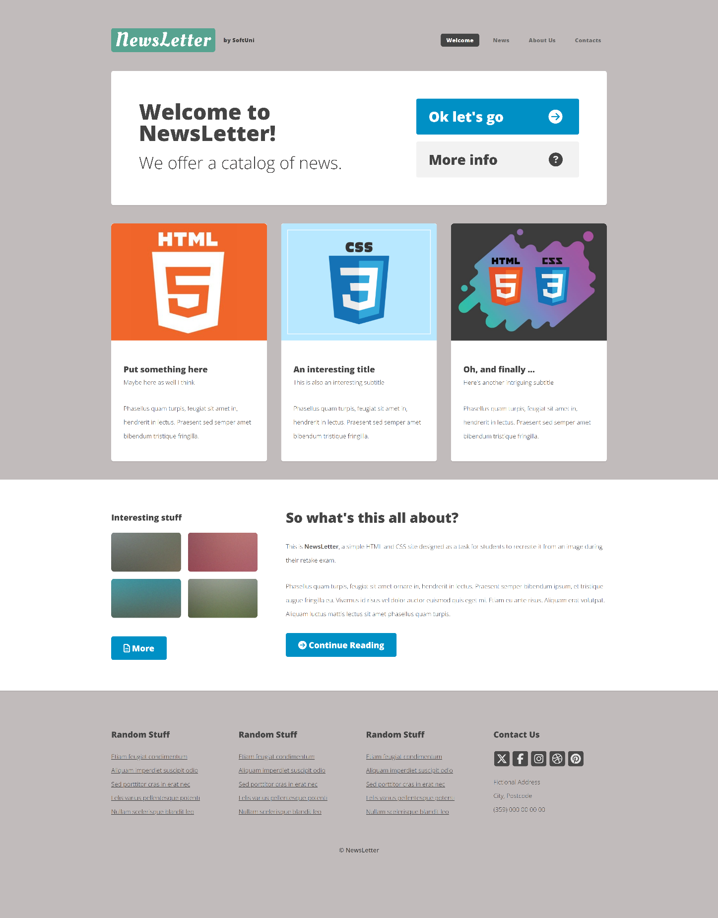

You are given the above screenshots + all required images.

## Output

The output should be valid **HTML5** + **CSS3** + **images** that implement the above web page.

## Constraints

* Use fonts 'Oleo Script', serif and 'Open Sans', sans-serif – they are already imported in CSS file.
* Hint: You will need 'Oleo Script' in the logo.
* The site should open correctly in the latest version of Chrome

**IMPORTANT: Do not change the structure of the provided exam resources. You may create files, but do not create new folders, rename existing ones, or move them to other directories.**

## Hints:

* **Background**: Use a **color picker tool** to identify the background color of the image and apply it to the frontend design.
* **Icons with Font Awesome**: Use **Font Awesome** to include icons in your frontend design. For the "Contact Us" section, you will need icons for **X (Twitter)**, **Facebook**, **Instagram**, **Dribbble** and **Pinterest**.